**Social Security Column**

YOUR PERSONAL MY SOCIAL SECURITY ACCOUNT IS FOR EVERY STAGE IN YOUR LIFE

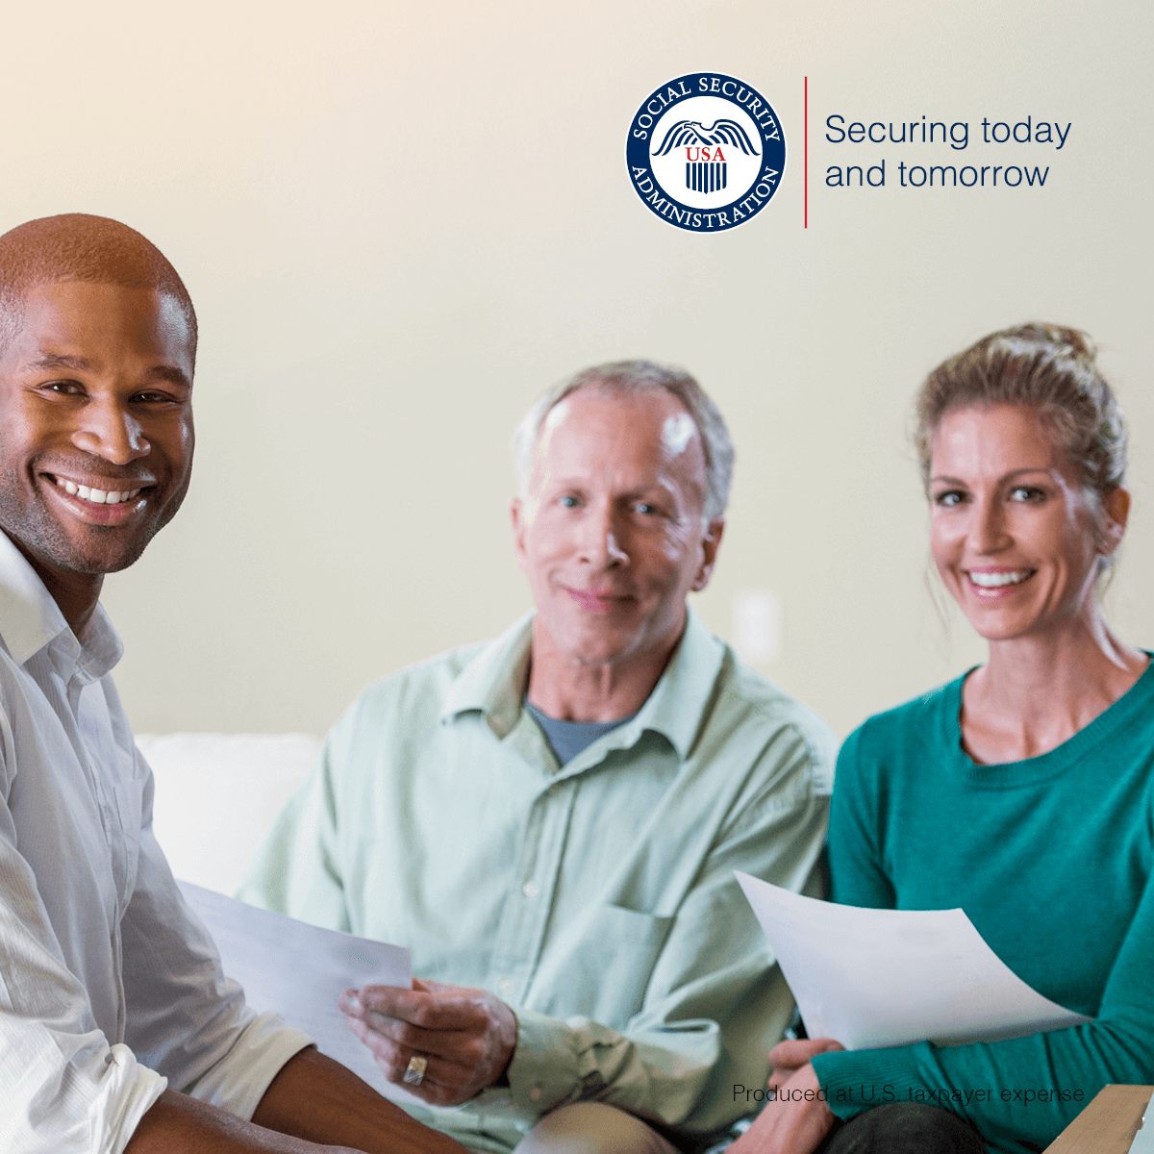

Your personal *my* Social Security account is here for you at every stage of your life. You don’t have to be retired or even close to retirement to take advantage of it. With an account, you can conduct much of your Social Security business online. For example, you can request a replacement Social Security card (in most states and the District of Columbia).

If you are not receiving benefits, you can use your personal *my* Social Securityaccount to:

* Get personalized retirement, spouse, or disability benefit estimates.
* Get your *Social Security Statement.*
* Get instant proof that you do not receive benefits.

If you already receive Social Security benefits, use your account to:

* Change your address. (Social Security benefits only)
* Change your direct deposit information. (Social Security benefits only)
* Get instant proof that you do receive benefits.
* Print your SSA-1099.

Please encourage your family and friends to create their personal *my* Social Security account at [www.ssa.gov/myaccount](https://www.ssa.gov/myaccount/).

###