**Social Security Column**

# SOCIAL SECURITY INSTALLS NEW KIOSKS TO IMPROVE CUSTOMER CHECK-IN PROCESS

By <Name>

Social Security <Title> in <Place>

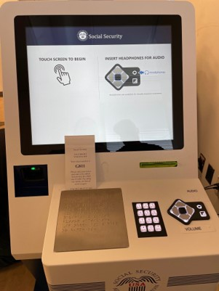

At Social Security we strive to make our services more accessible while maintaining your privacy. We installed new kiosks in most of our local offices to make it easier for you to check in and conduct business with us. The kiosks are private, easy to use without assistance, and provide consistent service to our customers.

Modifications to earlier screens have improved the check-in process, especially for our customers who are blind or have low vision. Each kiosk is compliant with the Americans with Disabilities Act (ADA) and includes the following features:

* Accessible keypads.
* Audio headphone jacks (complimentary headphones are available upon request).
* Braille instructions for how to use the kiosk and report any accessibility issues.
* Built-in thermal printers and ticket dispensers.
* Enhanced 508-compatible check-in software.
* Touchscreen monitors with privacy filters.

These kiosks are just one more way we’re improving the customer service experience in our offices. Last year, we began offering Mobile Check-in Express. It allows customers to use their mobile device to scan a QR code at their local office to check in for scheduled and walk-in appointments.

By turning on their device’s location services and mobile notifications, visitors receive:

* An electronic ticket so they know their place in line.
* An alert when an employee is ready to help them.
* Information about their interview location.
* An invitation to participate in our feedback survey.

With our new kiosks and Mobile Check-In Express, our check-in process has never been easier. To learn more about our commitment to accessibility, visit [www.ssa.gov/accessibility](https://www.ssa.gov/accessibility/index.html).

# # #