**Social Security Column**

PROTECTING YOURSELF FROM QR CODE FRAUD

**By <Name>**

**Social Security <Title> in <Place>**

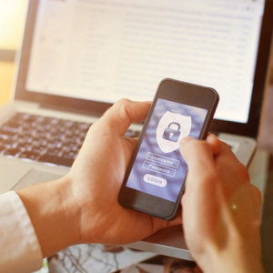

Quick Response codes, better known as QR codes, are a very popular way to get information. QR codes are scannable barcodes that will direct you to a website. However, scammers can create QR codes to trick people into visiting a fraudulent website or downloading malware that compromises their personal information.

For example, scammers may:

* Cover official QR codes with fake ones on parking meters, menus, or magazines.
* Send QR codes via email or text message pretending to be from delivery companies.
* Request that you confirm your information due to suspicious activity on your account using imposter QR codes.
* Place harmful codes on social media advertisements.

Here are some tips to avoid related scams.

**Verify the Source**

Before scanning a QR code, make sure it comes from a trusted and reliable source. Legitimate QR codes from Social Security will always send you to a safe and secure webpage at [www.ssa.gov](http://www.ssa.gov).

**Inspect the Code**

Scammers may use tactics that mirror a legitimate QR code. Take a moment to examine the QR code closely. Look for any signs of tampering, unusual colors, or misspellings. If something seems suspicious, it’s best to avoid scanning the QR code.

**Be Cautious of Unsolicited QR Codes**

Avoid scanning unsolicited QR codes received via email or text message. Be aware of codes from unknown sources. We will never send a QR code via text or email asking you to confirm your information.

**Be Aware of Urgent Requests Using QR Codes**

Fraudsters often pretend to be government officials and use fake QR codes to defraud people. For example, a scammer may pose as a Social Security employee claiming that you have an outstanding debt or there’s a problem with your account and demanding immediate payment. A scammer may send fake QR codes via text or email requesting the payment. Remember, Social Security will never request any form of payment using a QR code.

**Stay Informed**

Stay up to date on the latest QR code fraud and scams. Follow trusted sources such as cybersecurity blogs, news outlets, and official government websites for updates.

QR codes are an easy and convenient way to get information, but it’s important to remain vigilant when using them.

For more information, you can review the Federal Trade Commission Consumer Alert at [www.consumer.ftc.gov/consumer-alerts/2023/12/scammers-hide-harmful-links-qr-codes-steal-your-information](http://www.consumer.ftc.gov/consumer-alerts/2023/12/scammers-hide-harmful-links-qr-codes-steal-your-information).

You can report suspected Social Security imposter scams to the Office of the Inspector General’s website at [www.oig.ssa.gov/report](http://oig.ssa.gov/report). We encourage you to learn more about fraud and scams on our *Protect Yourself from Scams* webpage at [www.ssa.gov/scam](http://www.ssa.gov/scam).

Please share this with those who may need it.

# # #