**Social Security Column**

SOCIAL SECURITY OMITS FOOD FROM IN-KIND SUPPORT AND MAINTENANCE CALCULATIONS

**By <Name>**

**Social Security <Title> in <Place>**

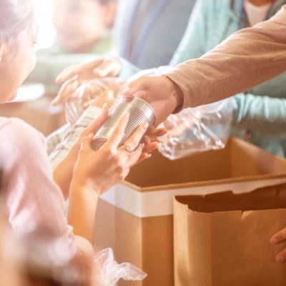

Supplement Security Income (SSI) provides monthly payments to adults and children with a disability or blindness. It also provides monthly payments to adults aged 65 and older, who have limited income and resources. SSI benefits help pay for basic needs like rent, food, clothing, and medicine. People applying for and receiving SSI must meet eligibility requirements, including income and resource limits.

Under our current rules, we include food assistance as unearned income when calculating In-Kind Support and Maintenance (ISM). We understand this rule could affect your SSI eligibility or reduce your payment amount, so we made changes. Beginning September 30, 2024, we are no longer counting food that someone gives you as income when we figure SSI payments. This new rule removes a critical barrier for SSI eligibility due to informal food assistance from friends, family, and community networks of support.

For more information on the SSI program, including who is eligible and how to apply, visit [www.ssa.gov/ssi](https://www.ssa.gov/ssi).

Please share this with those who may need it.

# # #