**Social Security Column**

social security VIDEO CONNECT: CONNECT WITH US FROM anYWHERE

**By <Name>**

**Social Security <Title> in <Place>**

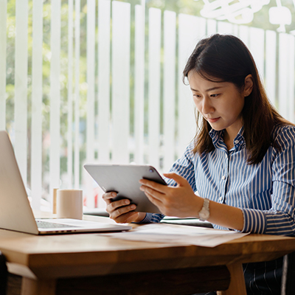

We continue to find ways to make doing business with us easier. With our Social Security Video Connect option, you can conduct business with us using video on your personal device, from your preferred location.

Social Security Video Connect is available for:

* No-change replacement Social Security cards (U.S. citizens only).
* Date of birth corrections (U.S. citizens only).
* Benefit applications.
* Redeterminations.
* Overpayments.
* Medicare.

**How to get started**

To get started with this new service, you will need a computer, tablet, or smart phone with a webcam and internet access. Once you have your device, please complete the following steps:

1. Contact your local Social Security office or call 1-800-772-1213 between 8:00 a.m. and 7:00 p.m., Monday through Friday to schedule a video appointment. A representative will determine if a video appointment is appropriate for you. If a video appointment isn’t appropriate for your needs, we can conduct the interview over the phone or in the office.
2. Provide your email address and phone number to receive an email with a link for the Microsoft Teams meeting.
3. Connect with us using that Microsoft Teams meeting link on the date and time of your appointment.

If you run into issues with Teams or need to reschedule your appointment, please contact your local Social Security office or call 1-800-772-1213.

We strive to improve our customer service and increase the ways you can connect with us. Please share this information with your friends and family who may need it – and post it on social media.

# # #