Social Security Column

# SOCIAL SECURITY CARDS ARE SAFER AT HOME

By <Name>

Social Security <Title> in <Place>

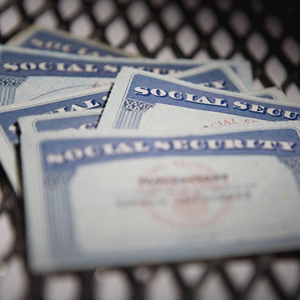

Scams to steal your personal information are at an all-time high. That’s why it remains critical to safeguard important personal documents like your Social Security card.

A Social Security card is not an identification document. In many situations, you only need to know your Social Security number (SSN). Your physical card is not necessary for most business needs.

Do you need evidence for work? There are several documents you can use instead of your card. These include:

* Birth Certificate.
* Permanent Resident Card or Alien Registration Receipt.
* Employment Authorization Document.
* Form I-94 or Form I-94A.

You do not need to show your physical card to apply for certain benefits. You can simply provide your SSN for benefits like:

* Housing.
* Health insurance.
* Food assistance.

You should also know your physical card is not required as evidence for the Department of Motor Vehicles. The only state that requires a physical card is Pennsylvania.  For all other states, acceptable evidence includes:

* W-2 forms.
* Form SSA-1099.
* Non-SSA-1099 forms.
* Pay stubs.

Keeping your card at home reduces the risk of loss or theft – and helps you keep your information safe. To learn more about keeping your card and information safe, please visit our Fraud Prevention and Reporting webpage at [www.ssa.gov/fraud](https://www.ssa.gov/fraud/).

*# # #*