**Social Security Column**

*SSA TALKS*: CHILD BENEFITS

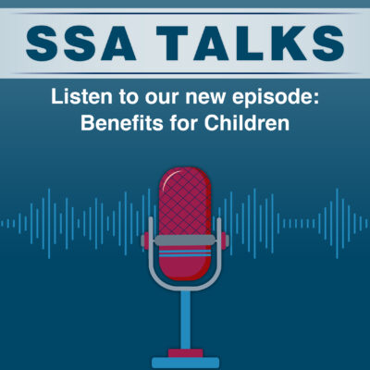

Kathleen Romig, Senior Advisor in the Office of the Commissioner, joined the latest episode of ***SSA Talks*** to discuss the Social Security benefits available to children. These include:

* **Survivors benefits** for children if their parent dies. For more information, please read our publication titled *Survivor Benefits* at [www.ssa.gov/pubs/EN-05-10084.pdf](https://www.ssa.gov/pubs/EN-05-10084.pdf).
* **Supplemental Security Income (or SSI)** for children if they have a disability or blindness and their families have limited income and resources. Visit our SSI webpage at [www.ssa.gov/ssi](https://www.ssa.gov/ssi/text-child-ussi.htm) to learn more.
* **Child benefits also known as “family benefits”** on the record of a parent receiving retirement or disability benefits. For more information, please read our publication titled *Benefits for Children* at [www.ssa.gov/pubs/EN-05-10085.pdf](https://www.ssa.gov/pubs/EN-05-10085.pdf).
* **Social Security Disability Insurance Benefits for Youth with Disabilities** for adults who have a disability that began before they reached age 22. These benefits are paid from their parent’s Social Security earnings record. For more information, please read our publication titled *Benefits for Children with Disabilities* at [www.ssa.gov/pubs/EN-05-10026.pdf](https://www.ssa.gov/pubs/EN-05-10026.pdf).

As an advocate and the mother of a child with disabilities, Kathleen knows well the challenges that children and their families encounter. During the episode she discusses how Social Security benefits and SSI help children. She also explains how we are taking more proactive steps to reach children who may be eligible for our benefits and programs.

You can listen to the episode on our ***SSA Talks*** webpage at [www.ssa.gov/news/audio-series.html](http://www.ssa.gov/news/audio-series.html) and subscribe to receive alerts about future episodes. You can also listen to previous episodes like “Commissioner O’Malley’s Top Priorities” and “Will Social Security be there when i retire?”.

For more information and news about Social Security, check out our *Communications Corner* webpage at [www.ssa.gov/news](http://www.ssa.gov/news).

Please share this with your friends and family – and post it on social media.

###