**Social Security Column**

# SOCIAL SECURITY’S TOP 5 SCAM AWARENESS ARTICLES

By <Name>

Social Security <Title> in <Place>

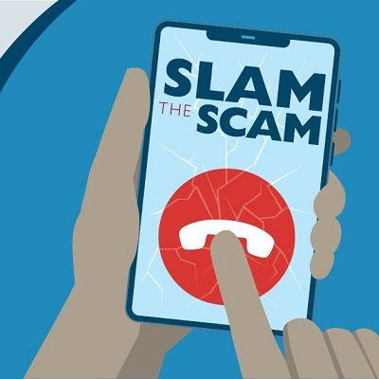

Did you join us for **Slam the Scam Day** in March?  If so, you know how important it is to raise awareness about government imposter scams.  That’s why we want you to have all the information you need to protect yourself.  Check out our **top 5 scam awareness articles** below:

1. We work with our Office of the Inspector General (OIG) to protect you from scams that use Social Security as bait. In *How We Protect You from Misleading Advertising and Communications*, we detail what to do if you receive a suspicious advertisement or imposter communication.  Please see [blog.ssa.gov/how-we-protect-you-from-misleading-advertising-and-communications](https://blog.ssa.gov/how-we-protect-you-from-misleading-advertising-and-communications/).
2. Identity theft affects millions of people each year and causes serious harm.  Here are 10 ways to protect yourself by securing your personal information at [blog.ssa.gov/10-ways-to-protect-your-personal-information-2](https://blog.ssa.gov/10-ways-to-protect-your-personal-information-2/).
3. Financial crime against all Americans is an ongoing problem.  People living with dementia have a higher risk of becoming victims of fraud.  You can learn how to minimize this risk for your loved ones at [blog.ssa.gov/minimizing-the-risk-of-scams-for-people-living-with-dementia](https://blog.ssa.gov/minimizing-the-risk-of-scams-for-people-living-with-dementia/).
4. Fraudsters also target veterans, active duty service members, and their families.  To learn what to look for and how to help the veterans and military members in your life, check out [blog.ssa.gov/stay-alert-fraudsters-target-veterans-active-duty-service-members-and-their-families](https://blog.ssa.gov/stay-alert-fraudsters-target-veterans-active-duty-service-members-and-their-families/).
5. Quick Response (QR) codes are very popular these days. A QR code is a scannable barcode that directs you to a website or social media account. Did you know scammers place fake QR codes on top of official ones?  It’s among the latest trends we list in this post to combat scams at [blog.ssa.gov/new-years-resolutions-to-combat-scams](https://blog.ssa.gov/new-years-resolutions-to-combat-scams/).

We encourage you to review these articles and bookmark them for future use.  Please share this information with friends and family to help us spread the word about scams.

###