Monthly Information Package

April 2024

Columns & Features

HOW TO SPOT AN IMPOSTER SOCIAL MEDIA ACCOUNT 2

SOCIAL SECURITY’S TOP 5 SCAM AWARENESS ARTICLES 4

PLAN FOR YOUR FUTURE DURING FINANCIAL LITERACY MONTH 6

SOCIAL SECURITY SUPPORTS SMALL BUSINESSES 8

MY SOCIAL SECURITY: IT’S NOT JUST FOR RETIREES 10

Produced at U.S. taxpayer expense.

Social Security Column

# HOW TO SPOT AN IMPOSTER SOCIAL MEDIA ACCOUNT

By <Name>

Social Security <Title> in <Place>

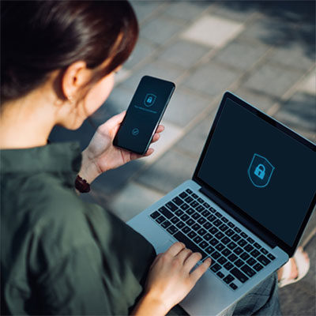

Want to learn how to spot fake Social Security social media accounts? The tips below will help you protect yourself and your family.

**How fraudsters create imposter accounts**

Fraudsters create imposter social media pages and accounts using Social Security-related images and vocabulary, making them appear as if they’re associated with or endorsed by us. They also create imposter social media pages of Social Security and OIG officials, such as the Commissioner or the Inspector General.

**Protect your personally identifiable information**

We will ***never*** ask for sensitive information through social media as these channels are not secure. Sometimes, users are asked to enter their financial information, Social Security number (SSN), or other sensitive information. This is a red flag, and often an indication of a fraudulent account.

**How to spot a fake social media account**

Identifying an imposter account may seem difficult at first, but there are a few things you can look for right away. You will want to focus on the following:

* How many people follow the imposter page. In most cases, fake pages have a very low number of followers as compared to Social Security’s official page.
* Improper punctuation.
* Links to pages not on SSA.gov.
* Advertisements for forms or other Social Security documents for a price.
* Incorrect social media handles. To view the list of our official social media channels, we encourage you to visit [www.ssa.gov/socialmedia](http://www.ssa.gov/socialmedia).

Please report suspected Social Security imposter scams — and other Social Security fraud — to the OIG’s website at [oig.ssa.gov/report](https://oig.ssa.gov/report). You can find more information about scams on our Protect Yourself from Scams webpage at [www.ssa.gov/scam](https://www.ssa.gov/scam).

Please share this information with your friends, family, and colleagues to help spread awareness about imposter social media accounts.

# # #

**Social Security Column**

# SOCIAL SECURITY’S TOP 5 SCAM AWARENESS ARTICLES

By <Name>

Social Security <Title> in <Place>

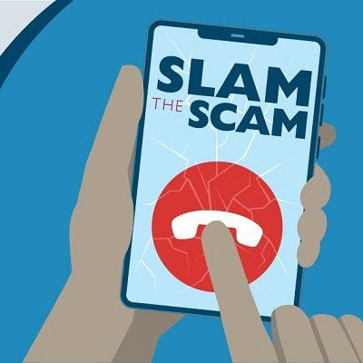

Did you join us for **Slam the Scam Day** in March?  If so, you know how important it is to raise awareness about government imposter scams.  That’s why we want you to have all the information you need to protect yourself.  Check out our **top 5 scam awareness articles** below:

1. We work with our Office of the Inspector General (OIG) to protect you from scams that use Social Security as bait. In *How We Protect You from Misleading Advertising and Communications*, we detail what to do if you receive a suspicious advertisement or imposter communication.  Please see [blog.ssa.gov/how-we-protect-you-from-misleading-advertising-and-communications](https://blog.ssa.gov/how-we-protect-you-from-misleading-advertising-and-communications/).
2. Identity theft affects millions of people each year and causes serious harm.  Here are 10 ways to protect yourself by securing your personal information at [blog.ssa.gov/10-ways-to-protect-your-personal-information-2](https://blog.ssa.gov/10-ways-to-protect-your-personal-information-2/).
3. Financial crime against all Americans is an ongoing problem.  People living with dementia have a higher risk of becoming victims of fraud.  You can learn how to minimize this risk for your loved ones at [blog.ssa.gov/minimizing-the-risk-of-scams-for-people-living-with-dementia](https://blog.ssa.gov/minimizing-the-risk-of-scams-for-people-living-with-dementia/).
4. Fraudsters also target veterans, active duty service members, and their families.  To learn what to look for and how to help the veterans and military members in your life, check out [blog.ssa.gov/stay-alert-fraudsters-target-veterans-active-duty-service-members-and-their-families](https://blog.ssa.gov/stay-alert-fraudsters-target-veterans-active-duty-service-members-and-their-families/).
5. Quick Response (QR) codes are very popular these days. A QR code is a scannable barcode that directs you to a website or social media account. Did you know scammers place fake QR codes on top of official ones?  It’s among the latest trends we list in this post to combat scams at [blog.ssa.gov/new-years-resolutions-to-combat-scams](https://blog.ssa.gov/new-years-resolutions-to-combat-scams/).

We encourage you to review these articles and bookmark them for future use.  Please share this information with friends and family to help us spread the word about scams.

###

**Social Security Column**

# PLAN FOR YOUR FUTURE DURING FINANCIAL LITERACY MONTH

By <Name>

Social Security <Title> in <Place>



We celebrate Financial Literacy Month (FLM) every April to promote financial education and well-being in the United States. FLM also serves as a reminder that Social Security is a vital part of any financial plan. Our online tools are here to help you understand your potential Social Security benefits and how they fit into your financial future.

You should periodically review your *Social Security Statement* (*Statement*) using your personal *my* Social Securityaccount at [www.ssa.gov/myaccount](https://www.ssa.gov/myaccount/). Your *Statement* is an easy-to-read summary of the estimated benefits you and your family could receive, including potential retirement, disability, and survivors’ benefits.

If you’re planning to retire, you can visit our *Plan for Retirement* webpage at [www.ssa.gov/prepare/plan-retirement](https://www.ssa.gov/prepare/plan-retirement). Here you can compare how different future earnings and retirement benefit start-dates might affect your future benefit amount.

Please tell your friends and family about the steps they can take to improve their financial knowledge by exploring their personal *my* Social Security account. If they don’t have an account, they can easily create one at [www.ssa.gov/myaccount](https://www.ssa.gov/myaccount/).

# # #

Social Security Column

# SOCIAL SECURITY SUPPORTS SMALL BUSINESSES

By <Name>

Social Security <Title> in <Place>



Running a small business can be a 24-7 endeavor. Managing employees, inventory, scheduling, services, and marketing can be challenging.

If you’re a small business owner, or you work for one, our online suite of services can help make your life easier. Our online business services at [www.ssa.gov/employer](https://www.ssa.gov/employer/) will save you valuable time when you file electronic W-2s and W-2Cs and verify employee names and Social Security numbers.

Small business owners can also take advantage of our Business Services Online at [www.ssa.gov/bso/bsowelcome.htm](https://www.ssa.gov/bso/bsowelcome.htm). You must register to use this free service. This service offers fast and secure online W-2 filing options to Certified Public Accountants, enrolled agents, and individuals who process W-2s and W-2Cs.

For more information about electronic wage reporting, please read our publication at [www.ssa.gov/pubs/EN-05-10034.pdf](https://www.ssa.gov/pubs/EN-05-10034.pdf).

# # #

Social Security Column

# MY SOCIAL SECURITY: IT’S NOT JUST FOR RETIREES

By <Name>

Social Security <Title> in <Place>



A personal *my* Social Security account can be helpful in so many ways. You can benefit from its personalized tools even if you are not retired or close to retirement.

With your personal *my* Social Security account, you can do much of your business with us online. You rarely need to call or visit a local Social Security office once you have one.

Let’s look at some of the features offered by an account.

If you do not receive benefits, you can:

* Request a replacement Social Security card (in most states and the District of Columbia).
* Check personalized retirement benefit estimates to compare different dates or ages to begin receiving benefits.
* Check the status of your Social Security application after you apply.
* Get proof that you do not receive benefits.
* Get your *Social Security Statement*.

If you already receive benefits, you can:

* Request a replacement Social Security card (in most states and the District of Columbia).
* Get a benefit verification or proof of income letter.
* Update your direct deposit (Social Security benefits only).
* Update contact information (Social Security benefits only).
* Get a Social Security tax form (1099/1042S).
* Opt out of receiving certain notices by mail and receive them in the secure Message Center.

Please help us spread the news! Let your family and friends know that they can create a personal *my* Social Security account today at [www.ssa.gov/myaccount](https://www.ssa.gov/myaccount).

*# # #*