**Tax Year 2023**

**Accessing Electronic Wage Reporting (EWR)**

**Suite of Services**

**Tutorial**

This tutorial demonstrates step-by step instructions for how to access EWR Suite of Services:

1. Forms W-2/W-3 Online (pilot)
2. Forms W-2c/W-3c Online (pilot)
3. Forms W-2/W-3 Online
4. Forms W-2c/W-3c Online
5. Upload Formatted Wage File
   1. Wage File Upload
   2. Special Wage Payment
6. AccuWage Online
7. Submission Status
8. Wage Report Status
9. Resubmission Notice (Request an Extension to file a Resubmission)
10. E-mail a Wage Report Expert (Contact SSA)
11. On the Social Security Administration (SSA) homepage (www.ssa.gov), in the “Services for” section at the bottom of the page, select the **Employers & businesses** link. The system displays the [Employer W-2 Filing Instructions & Information](https://www.ssa.gov/employer/) page.

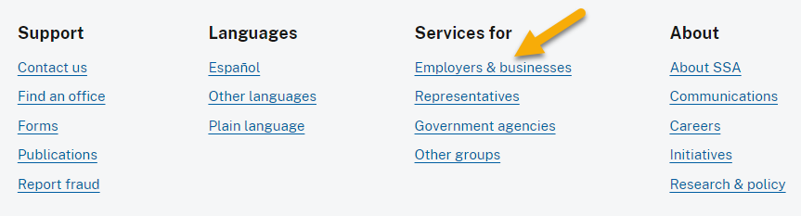

1. On the Employer W-2 Filing Instructions & Information page, select the **Business Services Online** button. The system displays the [Business Services Online](https://www.ssa.gov/bso/bsowelcome.htm) page.

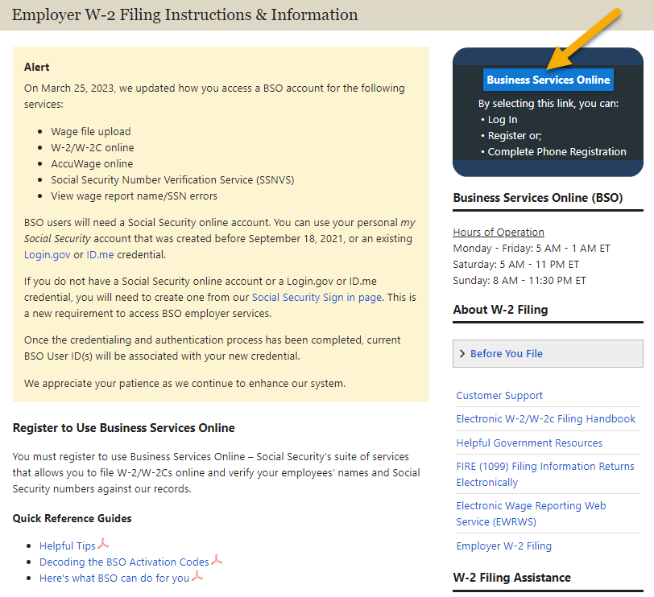

1. On the Business Services Online (BSO) page:

* Select the [Learn more about the updated registration process](https://www.ssa.gov/bso/bsowelcome.htm#registration) link to get familiar with the newly updated BSO registration process.
* Select the **Log in** link in the “Employers” section. The system displays the [Create an Account or Sign In](https://secure.ssa.gov/RIL/SiView.action?LVL=7&URL=/RIL/bso) page.
* Select the **Create account** link in the “Employers” section if you need to create an account.

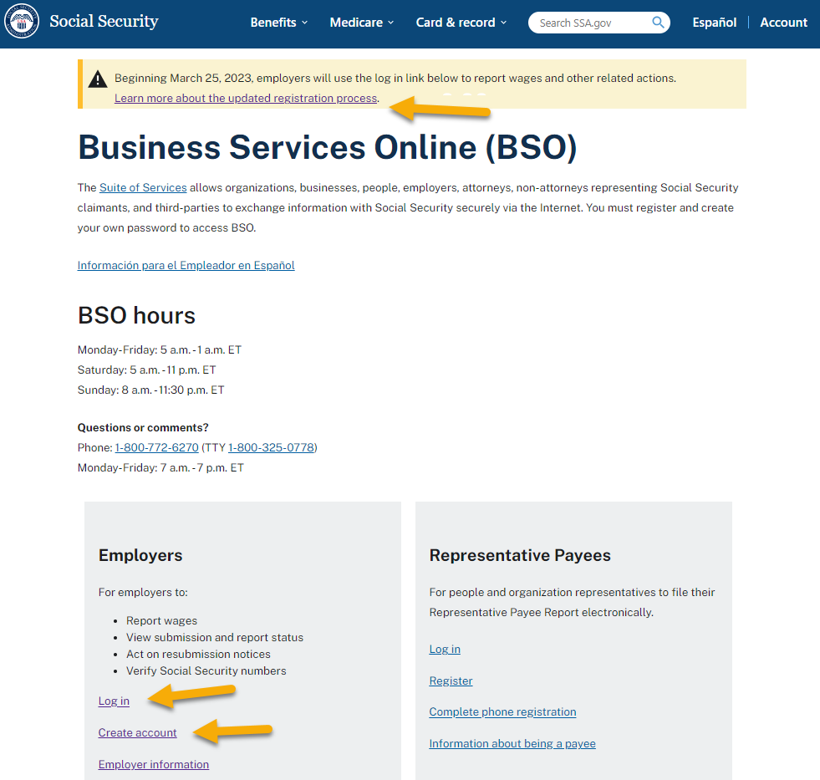

1. On the Create an Account or Sign In page, choose one of the three options to sign in. Each option will require you to enter a one-time code, then navigate to the Social Security Terms of Service page.

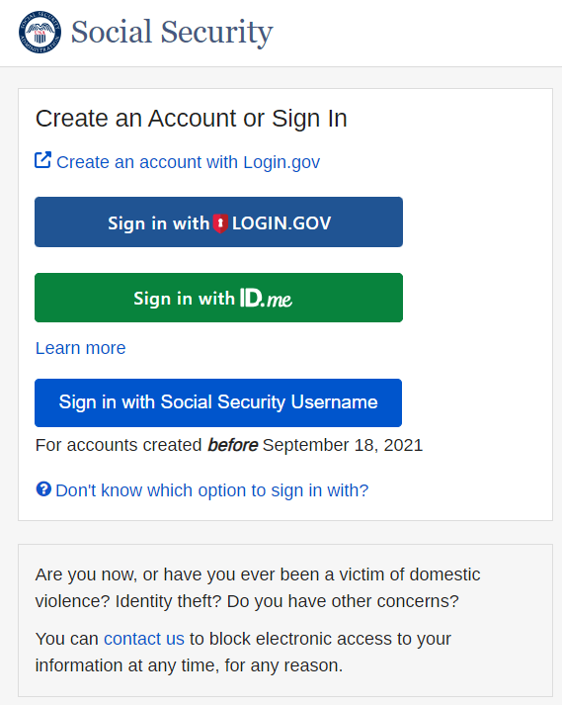

1. On the Social Security Terms of Service page, select the **I agree to the Terms of Service** check box, then select the **Next** button. The system displays the Social Security Privacy Act Statement page.

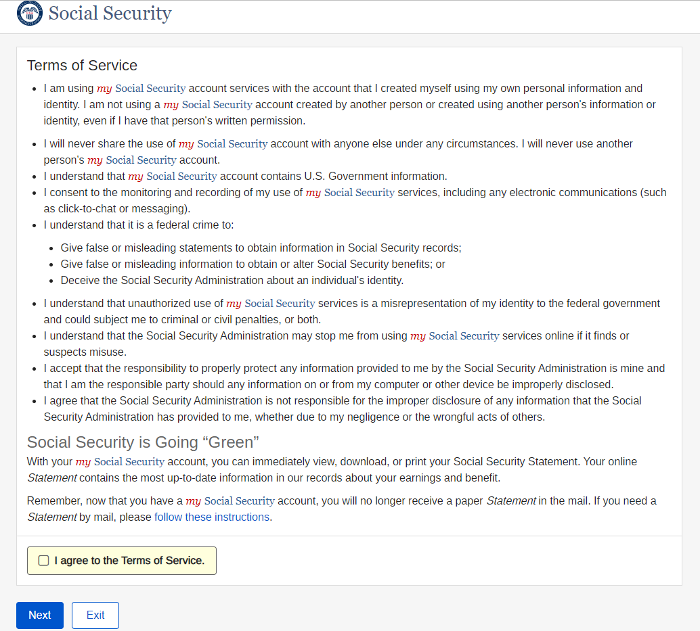

1. On the Social Security Privacy Act Statement page, select the **Next** button. The system displays the BSO User ID page.

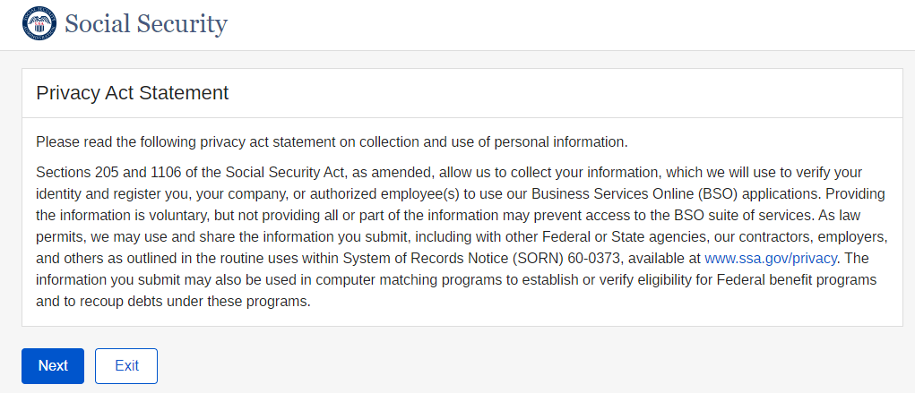

1. On the BSO User ID page, select a set of User ID/EIN, then select the **Next** button. The system displays the BSO Main Menu page.

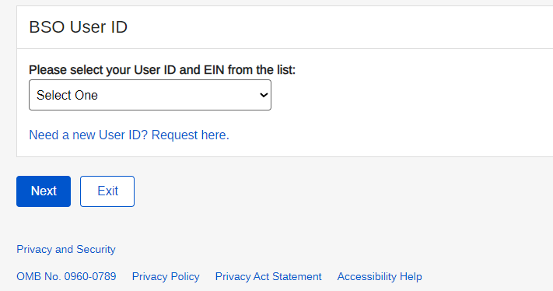

1. On the BSO Main Menu page, select the **Report Wages To Social Security** link. The system displays the Wage Reporting Attestation page.

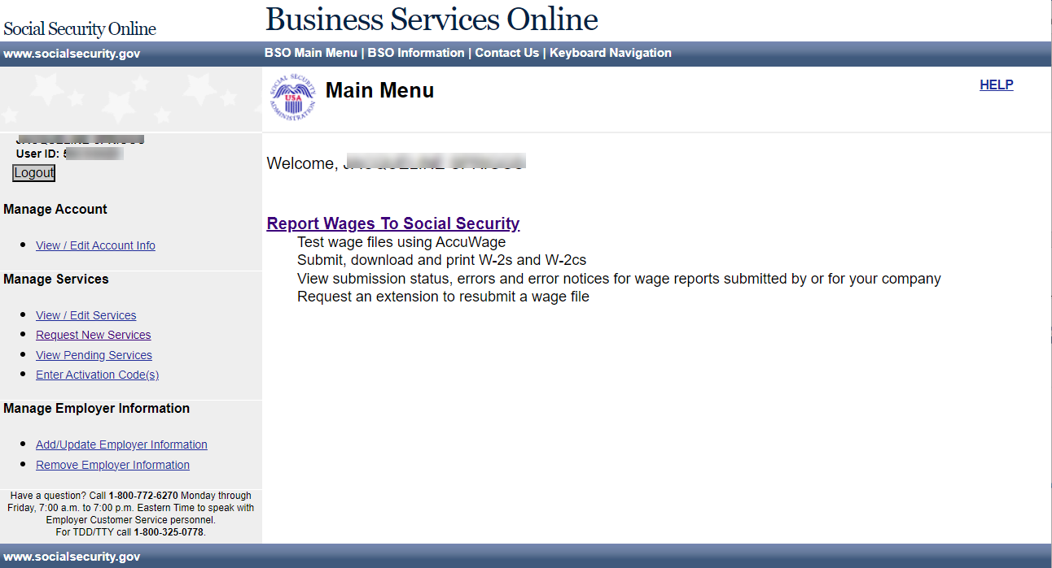

1. On the Wage Reporting Attestation page, select the **I Accept** button. The system displays the Report Wages to Social Security page (EWR homepage).

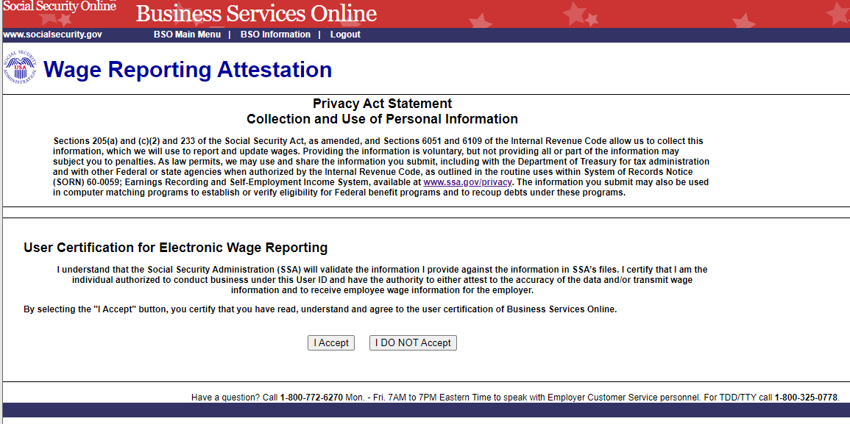

1. On the EWR homepage, you can access all EWR services, including:

* Forms W-2/W-3 Online
  + Pilot Program Participants—Forms W-2/W-3 Online (Pilot)
  + Create/Resume Forms W-2/W-3 Online (legacy)
* Forms W-2c/W-3c Online
* Upload Formatted Wage File
* AccuWage Online
* Submission Status
* Employer Report Status
* Resubmission Notice
* E-mail a Wage Reporting Expert (Contact SSA)

